Omar El-Seadawy
900150105

THE AMERICAN UNIVERSITY IN CAIRO
Department of Computer Science and Engineering

CSCE 4930 Selected Topics In Computer Science And Engineering
Practical Machine Deep Learning

Assignment 2

Fully Connected Neural Network on Cifar-100
Report

30/10/2018

1. Kindly find attached source code for both my own implementation and keras implementation.
Also attached are some of the runs I did during my assignment.

2. Data Preprocessing:
In my own implementation; Initially, I subtract the mean of my data from all data points in order to make the data zero-centered, then I normalize the data by all data points by 255 in order to make all values between 0 and 1.
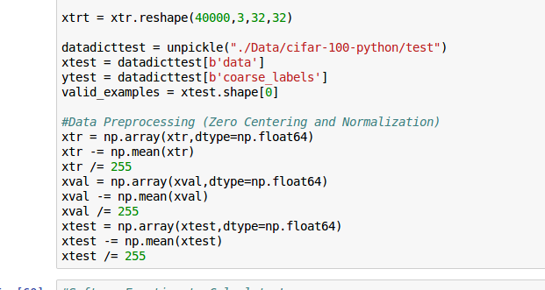
In Keras Implementation, I used data augmentation using ImageDataGenerator to provide more test points of rotated pictures and I also used Batch Normalization.

3. First of all, I divided training data into 40000 training data and 10000 validation data that will be used to fine tune the parameters.
Initially, I did a sanity check using normal stochastic gradient descent without any regularization to make sure that the model would over fit, I ran 300 Epochs, training data started with about 20% and went all the way up gradually to 100%.
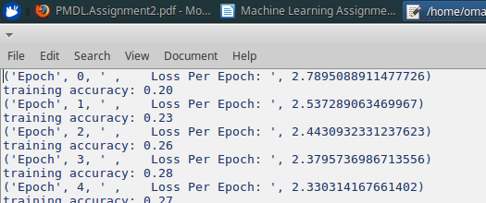

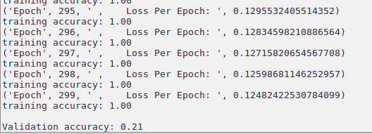

Next step was to change the gradient descent algorithm step by step, I first added momentum with 2e-3 learning rate and 1e-3 regularization strength, which produced about 35% Accuracy but it over fitted as well.

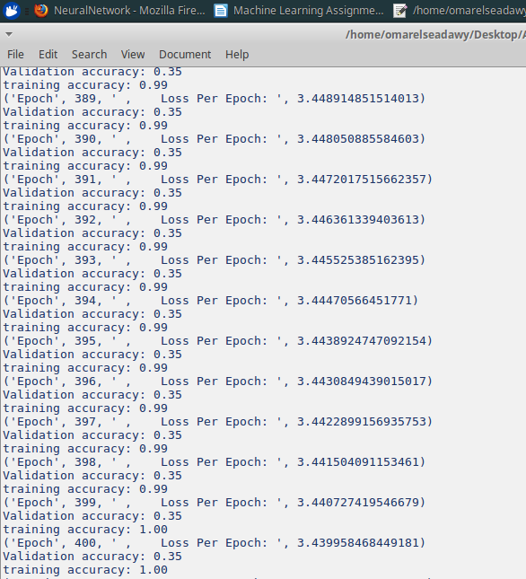

After that I finished implementing Adam which produced good results without over fitting
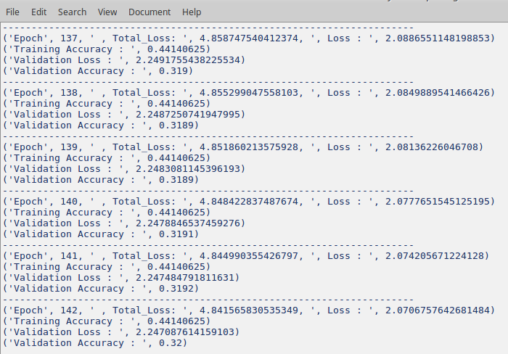

I also added Data Augmentation; however, it reduced the accuracy to 30% so I removed it because it might’ve had an implementation problem.
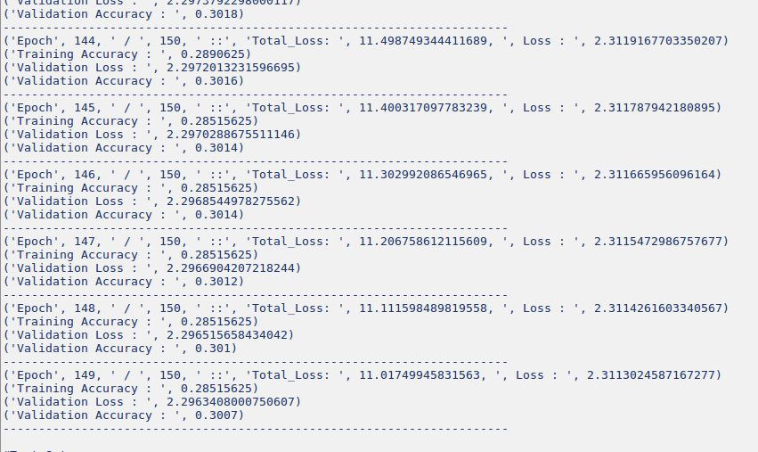

Finally, I stopped changing the learning rate and started varying the regularization strength (lambda) and vice versa until I found the best run at the time which produced about 35.88% Validation Accuracy and around 35% Testing Accuracy; however, I had a problem that I didn’t save the values of w’s and b’s and I forgot which seed I was using at the time. Therefore, I couldn’t produce CcrNs and Graph with those values.
The Architecture used for this model:
3 Hidden layers (1250,700,300) Neurons each
Hyper Parameters:
Learn rate : 5e-4
Lambda (Regularization Strength) = 0.01
beta 1 = 0.9
beta 2 = 0.999
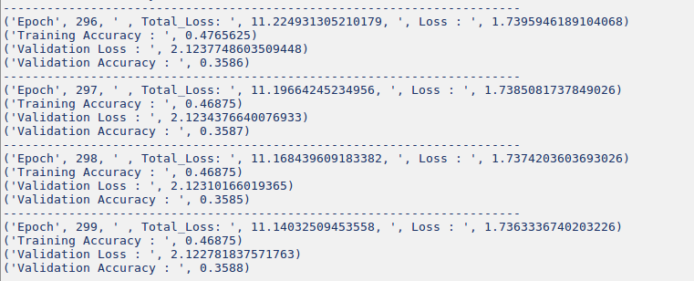
MiniBatchSize = 128
I had many changes in my code after that and I wasn’t able to re-run with the same high accuracy to be able to re-produce the graphs and CcrN. Therefore, I kept varying the values once more to be able to get as high accuracy as possible in the remaining time and here is the outcome. (Green for Training and Red for Validation). I stopped Training when the values of the losses and accuracies plateaued (saturated) because no change would happen to them after some amount of epochs.
In this architecture, I decrease the learning rate to half after half the amount of epochs.
The Architecture used for this model:
3 Hidden layers (1250,700,300) Neurons each
Hyper Parameters:
Learn rate : 5e-3 and drops by half
Lambda (Regularization Strength) = 1e-4
beta 1 = 0.9
beta 2 = 0.999
Mini Batch Size = 200

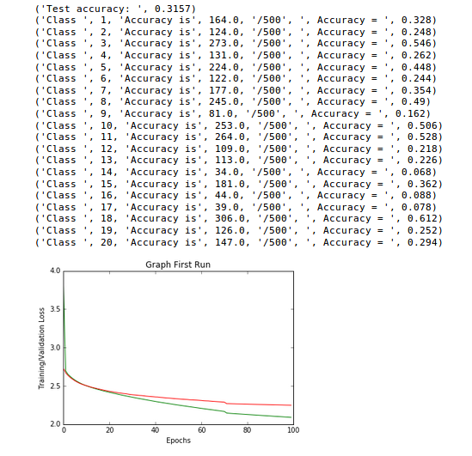
Moreover, I used Keras implementation of fully connected (Dense) Neural Network and Produced an accuracy of 52.19%
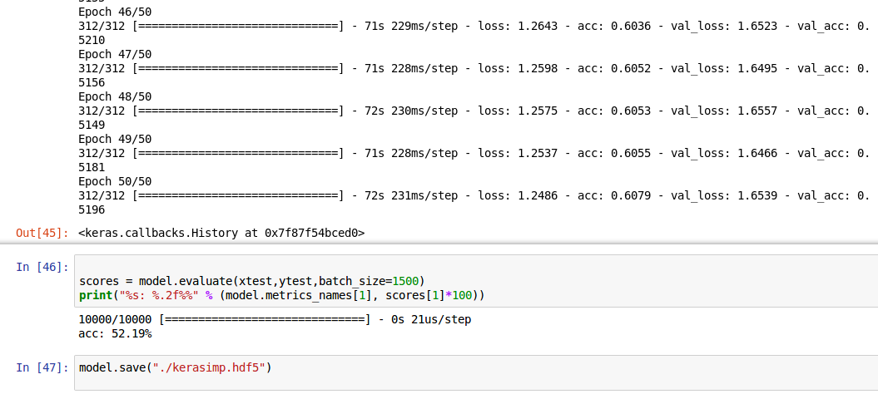

Assuming the highest value of my ACCR was 35.5% from the model with the missing graph and the value of keras’s accuracy was 52.19%
The Average Accuracy Outcome is 43.845%
The Accuracy is way higher than my KNN Implementation which produced an accuracy of 14.9%. Moreover, the accuracies of each class (CcrN) improved significantly for each class which shows the Fully connected neural network was way better in terms of classification

